1. Go to console.firebase.google.com
2. Login to reach the Add project option
   1. Add Project
   2. Enter a project name: “Chess” - click continue
   3. Disable the google analytics option
   4. Click Create project.
3. Open the chess project
4. Create a web app – by clicking the third option



1. Give app name - “chess” click register app
2. Inside Add firebase sdk that opens choose “use npm”
3. Inside the code that appears copy the “firebaseConfig” variable.

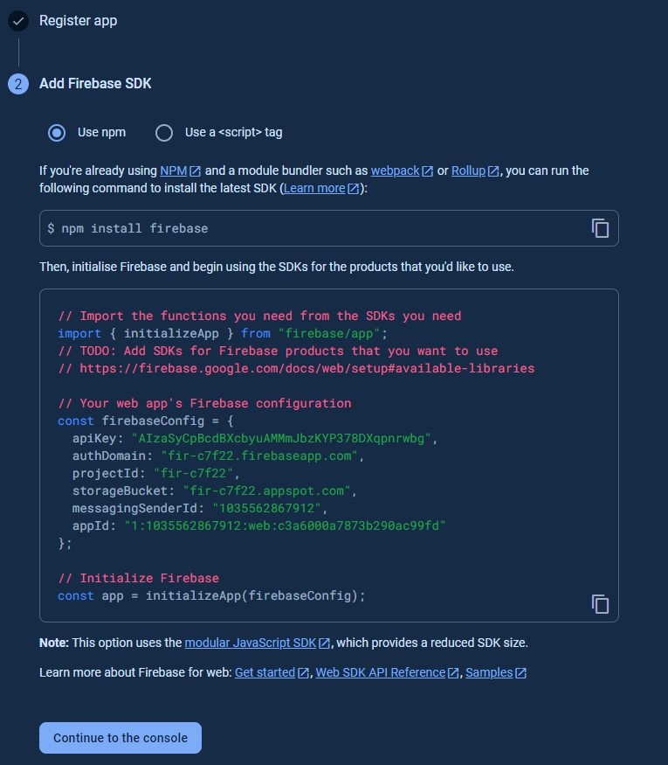

1. Click continue
2. Paste this new variable replacing the existing firebaseConfig variable in

Server > config > firebase.js

1. On the left vertical menubar, go to Project Settings
2. Inside Project Settings, go to Service Accounts
3. Firebase Admin SDK, choose Node js
4. Click “Generate new Private key” and generate key.
5. This will download a json file, rename the file to “firebaseService.json”
6. Paste this file inside config folder ( Server > config).

Enable authentication:

1. Go to project overview by clicking home, in left menu panel.
2. Go to authenticate :

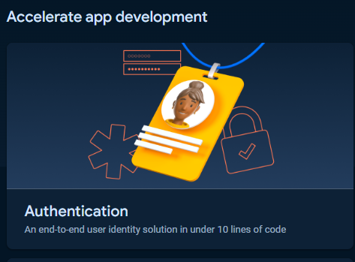

1. Get started
2. Inside sign-in method > sign-in providers > Email/Password
3. Enable the Email/Password
4. Click save